ELYM 328

Name: MNGOMEZULU TSHEPO
Student Number: 42090474
Date Conducted: 17 August 2026
Submission date: 24 August 2026

1. Aim
To provide instructional guidance on microcontroller software development, utilizing the PIC microcontroller family with particular emphasis on the PIC16F84 as a practical example.

2. Abstract
This laboratory report presents a comprehensive tutorial on microcontroller software development, concentrating on the PIC16F84A microcontroller. The document examines the fundamental aspects of the MPLAB IDE environment, debugging methodologies, and assembly language programming techniques for the PIC16F84A. The primary objective is to illustrate the complete workflow of composing, troubleshooting, and executing a straightforward program designed to increment a counter and output the resulting value to PORTC. Additionally, the report addresses typical programming errors encountered during the debugging phase and provides solutions for their resolution.

3. Objectives
- Comprehend the architectural design and operational characteristics of the PIC16F84A microcontroller.
- Develop proficiency in utilizing the MPLAB IDE for assembly code composition, assembly, and debugging.
- Design and implement a fundamental program that increments a counter and transmits the result to PORTC.
- Identify, examine, and resolve standard debugging complications.
- Acquire hands-on experience employing the MPLAB SIM simulator for program verification and testing.

4. Equipment
- Microchip MPLAB IDE software package
- PIC16F84A microcontroller (operated in simulation mode via MPLAB SIM)
- MPLAB SIM simulator (integrated component of the MPLAB IDE)

5. Introduction
The PIC16F84A represents an 8-bit microcontroller belonging to Microchip's Mid-Range product family, incorporating 1K x 14-bit program memory, 68 bytes of RAM, and 64 bytes of EEPROM. Its widespread adoption in embedded systems stems from its economical pricing, straightforward programming model, and comprehensive peripheral feature set. This laboratory exercise concentrated on developing software for the PIC16F84A using the MPLAB IDE, which furnishes an all-encompassing environment for authoring, troubleshooting, and simulating microcontroller applications. characteristics of the PIC16F84A pertinent to this laboratory exercise:
- RISC-based architecture supporting 35 instructions
- Harvard architecture featuring segregated program and data memory
- Interrupt functionality (external interrupts, timer interrupts, and port-change interrupts)
- I/O ports (PORTA and PORTB)
- Timer0 module for timing-related operations

6. Theory PIC16F84A Architecture
The PIC16F84A employs a RISC (Reduced Instruction Set Computer) architecture, facilitating rapid instruction execution, with the majority of instructions completing in a single cycle. Notable architectural features include:
- 13-bit Program Counter (PC) capable of addressing up to 8K x 14-bit program memory (though the PIC16F84A implements only 1K x 14-bit)
- 8-level hardware stack for managing subroutine calls and interrupt handling
- Special Function Registers (SFRs) responsible for peripheral control and device operation management

MPLAB IDE
MPLAB IDE serves as Microchip's integrated development environment for PIC microcontrollers, incorporating:
- Editor: For composing and modifying assembly or C language code
- Assembler/Compiler: Translates source code into machine-executable instructions
- Simulator (MPLAB SIM): Enables testing and debugging without physical hardware
- Debugger: Provides breakpoint functionality, single-step execution, and variable monitoring

Assembly Language Fundamentals
The laboratory program was developed using assembly language, offering direct hardware control capabilities. Essential instructions utilized include:
- MOVWF: Transfers data from the W register to a file register
- INCF: Increments the contents of a file register
- GOTO: Performs an unconditional jump to a specified label
- CALL: Invokes a subroutine

Debugging Methodology
The debugging process encompasses error identification and resolution. Common categories of errors include:
- Syntax errors: Improper instruction usage or label formatting
- Logical errors: Code execution yielding unexpected outcomes
- Hardware-related errors: Incorrect port or peripheral configuration
The MPLAB SIM simulator facilitates visualization of program execution flow and register states, streamlining error detection and correction.

7. Procedure
The laboratory exercise commenced with MPLAB IDE v8.91 environment configuration to establish a new project targeting the PIC16F84 microcontroller.

Project Creation
- Launched MPLAB IDE and initiated the Project Wizard (Project > Project Wizard) to create a new project
- Designated the PIC16F84 as the target device from the available device selection
- Configured the language toolsuite to employ the Microchip MPASM Assembler and MPLINK Linker for code assembly and linking
- Assigned a project name and saved it within a dedicated folder structure
- Incorporated the source file containing the initial program code for counter incrementation and PORTB display
- Added the linker script to ensure accurate memory mapping for the PIC16F84

Initial Program Development
The preliminary program was designed to accomplish the following tasks:
- Clear PORTC and configure it as an output port
- Initialize a counter variable (COUNT)
- Increment the counter and display the resulting value on PORTC
- Incorporate a delay loop to regulate the counter increment rate The initial code was subsequently assembled.

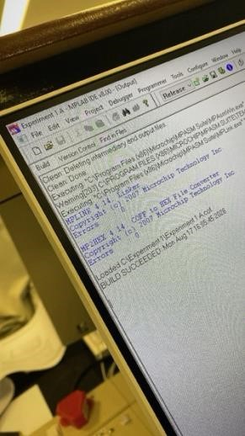
Figure 1: MPLAB IDE Build Output

Primary issues identified in the initial program:
- Incorrect usage of "WREG" instead of the working register "W"
- Redundant "IncCount" label
-Missing declarations for general-purpose variables including COUNT, DVAR, and DVAR2
Corrections implemented:
- "WREG" was corrected to "W"
- Duplicate "IncCount" label was eliminated
- Variables were properly declared
These modifications ensured successful program assembly, enabling proper counter initialization, incrementation, PORTC value display, and delay loop implementation for timing regulation. The debugging process emphasized the significance of appropriate register naming conventions, label usage, variable declarations, and bank selection in PIC16F84 assembly programming.
Following error resolution, the code was reassembled and tested utilizing the MPLAB SIM Simulator.
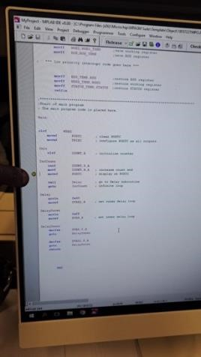
Figure 2: Final Corrected Code with Breakpoint set in MPLAB SIM.

8. Results
The initial code failed to assemble successfully due to the following complications:
- Undefined symbols (WREG, DVAR, DVAR2)
- Illegal opcodes resulting from incorrect mnemonics or register names
- Missing bank selection leading to improper register access
The raw code before debugging was documented. The assembly process generated error messages corresponding to the issues listed above.

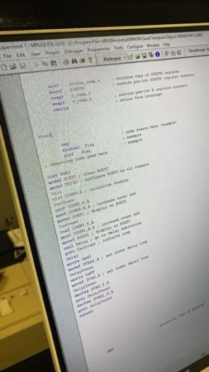
Figure 3: Raw Source Code Before Debugging.
After implementing all corrections described in the procedure, the code was reassembled successfully. The corrected program executed as intended, initializing the counter, incrementing it, displaying the value on PORTC, and implementing the delay loop to control the update rate. Simulation confirmed that the counter incremented correctly and the PORTC outputs reflected the expected binary values.

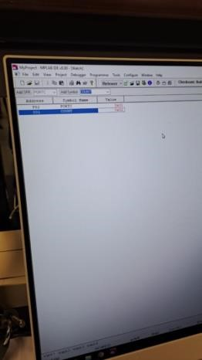
Figure 4: MPLAB Watch Window

9. Discussion

9.1 Undefined Symbols
- Error: The assembler generated "Symbol not previously defined" messages for PORTC, DVAR2, and COUNT
- Resolution: These errors were remedied by declaring the variables with appropriate directives
PORTC res 1
DVAR2 res 1
COUNT res 1

Duplicate Address Labels
- Error: The assembler reported "Address label duplicated or different in second pass" for the "IncCount" label
- Resolution: This was corrected by renaming the duplicate "IncCount" label to "IncCount_1"

Illegal Characters
- Error: Illegal characters were detected due to incorrect mnemonics containing extra operands
- Resolution: The extraneous operands were removed to ensure mnemonics possessed the correct number of operands

9.2 Variable Explanations

- W (Working Register)
Purpose: Serves as the working register within the PIC16F84, utilized for arithmetic and logical operations, as well as data transfer between memory locations
- PORTC
Purpose: A Special Function Register (SFR) representing Port C of the PIC16F84, employed for input/output operations. In this program, PORTC is configured as an output port for displaying counter values c) TRISC
Purpose: The data direction registers for Port C, configuring each pin as either input (1) or output (0). In this program, TRISC is set to 0 to configure all Port C pins as outputs d) COUNT
Purpose: A general-purpose variable storing the counter value, incremented in the main loop and displayed on PORTC e) DVAR and DVAR2
Purpose: Variables employed within the delay subroutine to generate time delays. DVAR2 sets the outer loop count while DVAR sets the inner loop count, forming a nested loop structure

Instruction Explanations
a) clrf (Clear f)
Purpose: Clears the contents of a register or variable (sets to 0) b) movwf (Move W to f)
Purpose: Transfers the contents of the working register W to a specified file register or variable
c) movlw (Move Literal to W)
Purpose: Loads a literal (constant) value into the working register W d) incf (Increment f)
Purpose: Increments the contents of a file register or variable e) movf (Move f)
Purpose: Transfers the contents of a file register or variable to the working register W or to itself
f) decfsz (Decrement f, Skip if Zero)
Purpose: Decrements a file register or variable and skips the subsequent instruction if the result equals zero; commonly used in countdown loops g) goto (Go to)
Purpose: Performs an unconditional jump to a specified program label h) call (Call Subroutine)
Purpose: Invokes a subroutine, storing the return address on the stack
i) return (Return from Subroutine) ii) Purpose: Returns from a
subroutine to the instruction immediately following the CALL

9.3 "Symbol not previously defined (PORTC)" Error Analysis
The error message "Symbol not previously defined (PORTC)" could arise from several causes:
- Missing Declaration
PORTC is a Special Function Register (SFR) in the PIC16F84, predefined in the include file P16F84.INC. If this include file was omitted or improperly referenced, or if the register name contained typographical errors, the assembler would fail to recognize
PORTC
- Typographical Errors
Misspelling PORTC (e.g., PORT C, PORTCc) would result in the assembler failing to identify it as a valid symbol
- Incorrect Bank Selection
While PORTC itself does not require explicit declaration, improper bank selection (when required) could cause access issues. However, PORTC is accessible across all banks, making this less likely as the primary cause d) Missing Include Directive
If the directive INCLUDE "P16F84.INC" was absent or incorrectly specified, the assembler would not recognize SFRs including PORTC
9.4 PORTB Characteristics
Purpose: An 8-bit bidirectional port suitable for general-purpose input/output operations Features:
- Each pin can be individually configured as input or output
- Weak internal pull-ups are available and can be enabled or disabled
- Pins RB0/INT and RB4-RB7 feature interrupt-on-change capabilities, generating interrupts upon input state changes.

TRISB Functionality
Purpose: Data direction registers for PORTB Function:
- Each bit in TRISB corresponds to a specific pin on PORTB
- Setting a TRISB bit to 1 configures the corresponding PORTB pin as input
- Clearing a TRISB bit to 0 configures the corresponding PORTB pin as output

9.5 Program Overview
The program developed during this laboratory session executes the following operations:

Initialisation
- The working register W is cleared, and its value is transferred to PORTC to clear the port
- The W value is also moved to TRISC, configuring all Port C pins as outputs
Counter Initialization
- The COUNT variable is cleared to initialize the counter to zero

Main Loop
- The counter (COUNT) is incremented
- The COUNT value is moved to the working register W and then to PORTC, displaying the counter value on Port C
- A delay subroutine is called to generate a time delay, regulating the update rate of the counter display on PORTC
- The program loops back to continue the counter incrementation process indefinitely

Delay Subroutine
- A nested loop structure generates the delay, with DVAR2 controlling the outer loop and DVAR controlling the inner loop
- The decfsz instruction decrements loop counters and skips the next instruction when zero is reached, effectively creating the delay loop
In summary, the program continuously increments a counter and displays the value on Port C, with a delay loop governing the update frequency. This demonstrates fundamental I/O operations, counter management, and delay loop implementation in PIC16F84 assembly programming.

10. Conclusion

This laboratory session provided a comprehensive introduction to microcontroller software development, specifically employing the PIC16F84 and MPLAB IDE environment. Through the processes of coding, debugging, and simulating an assembly program, several essential concepts and abilities were reinforced:

Understanding the PIC16F84 Architecture
The laboratory emphasized the critical nature of comprehending the PIC16F84's memory organization, register structure, and I/O ports. Particular attention was devoted to Special Function Registers (SFRs) such as PORTC and TRISC, along with generalpurpose variables including COUNT, DVAR, and DVAR2.

Debugging Proficiency
Debugging the initial code revealed prevalent issues including undefined symbols, duplicate labels, illegal characters, and incorrect mnemonics. These problems were systematically addressed by ensuring proper variable declarations, correcting syntax errors, and verifying bank selection. This process underscored the importance of meticulous attention to detail and methodical troubleshooting in assembly programming.

Assembly Language Constructs
The program incorporated fundamental assembly instructions including clrf, movwf, movlw, incf, movf, decfsz, goto, call, and return. Understanding the purpose and correct usage of these instructions proved essential for producing functional code.

MPLAB IDE Utilization
The MPLAB IDE proved invaluable for code composition, assembly, and simulation. Features including the simulator, watch window, and debugging tools were essential for verifying program behavior and identifying errors.

Practical Implementation
The program demonstrated a practical application of controlling an output port (PORTC) to display an incrementing counter value. The inclusion of a delay loop illustrated timing control in embedded systems, a critical capability for numerous real-world applications.

Documentation Significance
Consulting the PIC16F84A datasheet proved crucial for understanding register functionality including PORTB and TRISB. This reinforced the importance of referencing technical documentation when working with microcontrollers.

Problem-Solving and Analytical Thinking
The process of identifying and resolving errors enhanced problem-solving capabilities and analytical thinking. It highlighted the necessity of logical reasoning and systematic debugging to ensure intended program operation.
In conclusion, this laboratory session successfully introduced microcontroller software development fundamentals using the PIC16F84. It provided practical experience with assembly programming, debugging techniques, and development tools including MPLAB IDE. The skills and knowledge acquired form a solid foundation for continued exploration and development in embedded systems. Future work could involve expanding the program to incorporate interrupts, interfacing with external hardware, and exploring advanced PIC16F84 features.

References

- Microchip Technology Inc. (2001) PIC16F84A Data Sheet. [Online]. Available at: Microchip Technology Inc.

- Microchip Technology Inc. (2006) MPLAB IDE Quick Start Guide. Document Number: DS51281. [Online]. Available at: Microchip Technology Inc.

- Microchip Technology Inc. (1997) PICmicro Mid-Range MCU Family Reference Manual. Document Number: DS33023. [Online]. Available at: Microchip Technology Inc.

